

Medical lab automation system (mlas)

UML DIAGRAMS



January 1, 2015

R Naresh (13CS30024) BARNOPRIYO BARUA (13CS30009)

SOFTWARE ENGINEERING ASSIGNMENT

Table of Contents

1 Use Case Diagrams 2

1.1 Total Diagram (Containing all User Classes) 2

1.2 User Class – Patient 2

1.3 User Class – Management 3

2 Class Diagram 4

3 Sequence Diagrams 5

3.1 Taking a Test and Collection Of Test Report 5

3.2 Remove a Test 6

3.3 Add a Test 6

3.4 Place Order for Shortage of stock 7

4 Collaboration Diagrams 8

4.1 Taking a Test and Collection Of Test Report 8

4.2 Place Order for Shortage of stock 8

4.3 Remove Test 8

4.4 Add a Test 9

5 Activity Diagrams 10

5.1 Take Test and Collect Bill 10

5.2 Collect Bill 11

5.3 Add Test 11

5.4 Remove a Test 12

# Use Case Diagrams

## Total Diagram (Containing all User Classes)

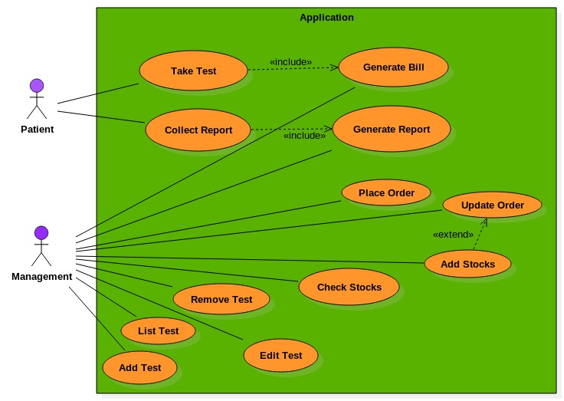

## User Class – Patient

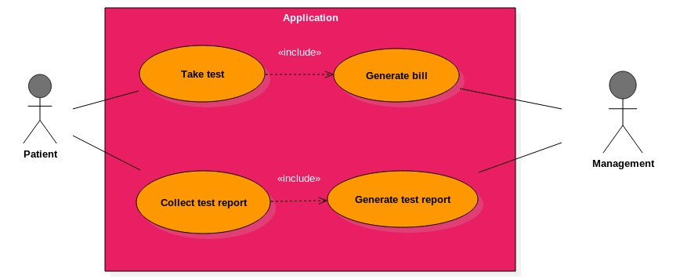

## User Class – Management

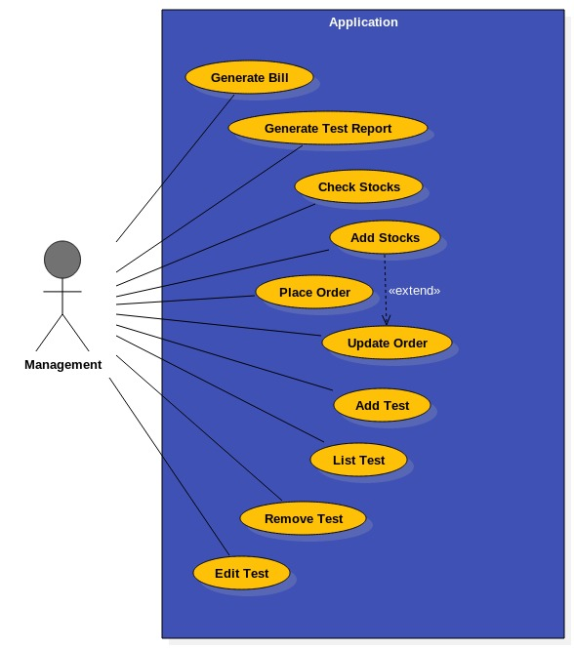

# Class Diagram

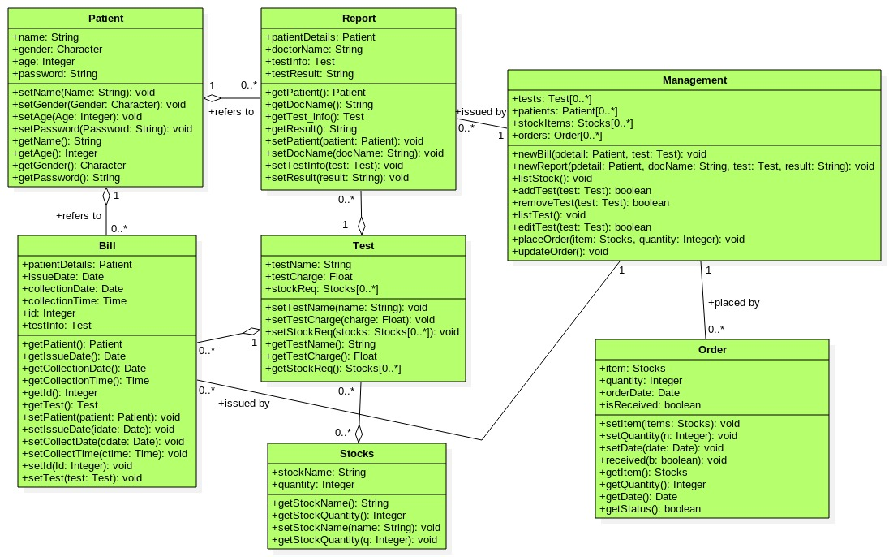

# Sequence Diagrams

## Taking a Test and Collection Of Test Report

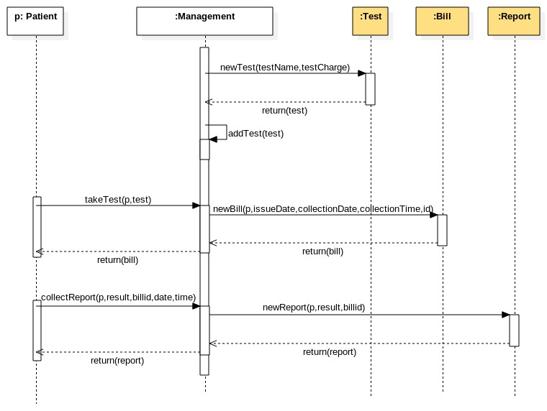

## Remove a Test

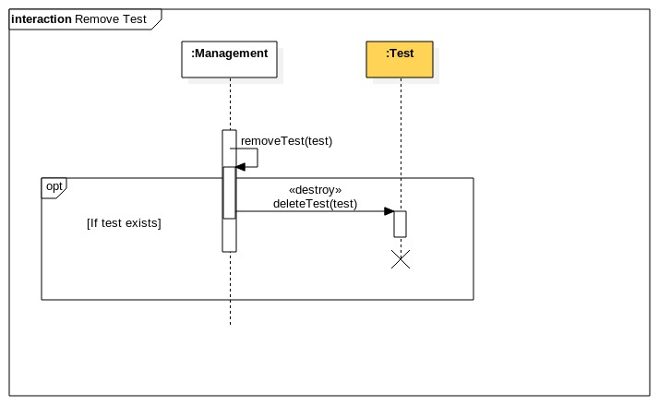

## Add a Test

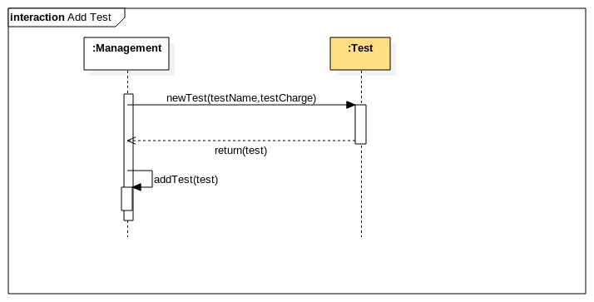

## Place Order for Shortage of stock

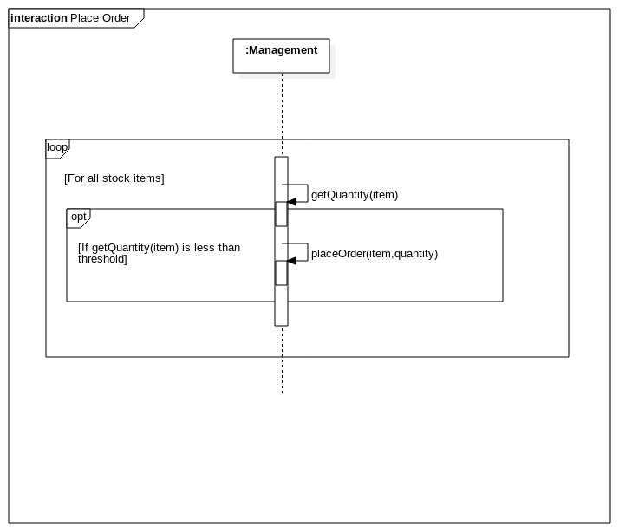

# Collaboration Diagrams

## Taking a Test and Collection Of Test Report

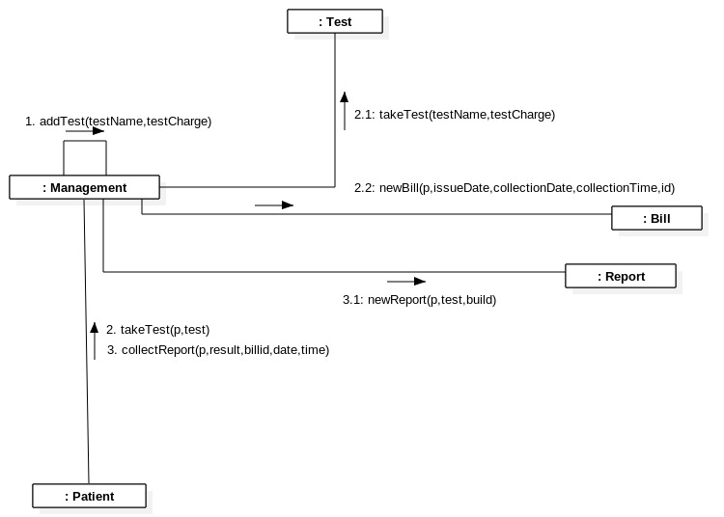

## Place Order for Shortage of stock

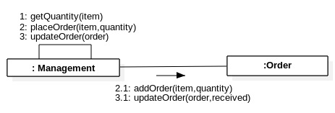

## Remove Test

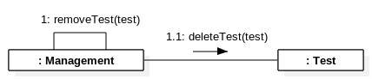

## Add a Test

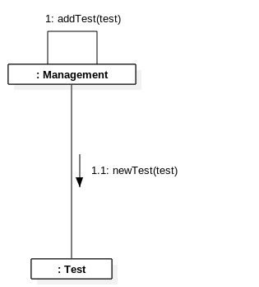

# Activity Diagrams

## Take Test and Collect Bill

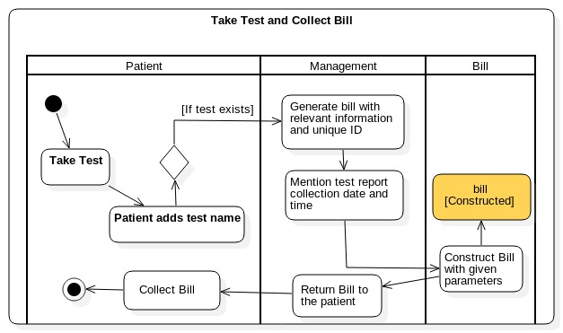

## Collect Bill

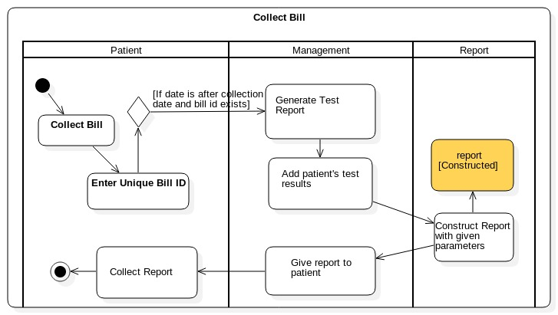

## Add Test

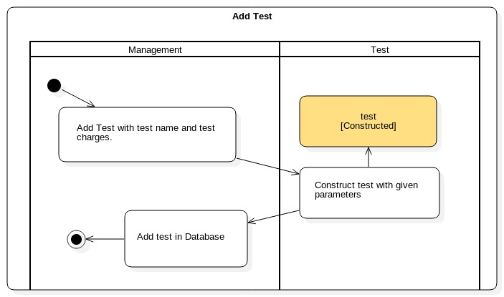

## Remove a Test

